 2022

B. Tech. Project

Guidelines

Guidelines for Minor/Major Project

Projects play a very important role in overall development of a student to learn the aesthetics of industry. The objective of working with projects is to understand the importance of teamwork, deadlines and documentation.

Department of Computer Science & Engineering

**HMR Institute of Technology**

**GUIDELINES FOR MAJOR/MINOR PROJECT**

**PROJECT:** A Project is an important component of learning in a program where a student learns to preparea project as per his/her interest in order to present a new technical solution on a existing or a new problem. Students can learn to prepare themselves for industry through the reports and presentations on a particular topic.

**OBJECTIVE OF PROJECT:** To provide an opportunity to students to demonstrate the ability to develop theskills in innovation and development towards problem and bringing the society a new solution.

**1. ASSESSMENT**

|  |  |
| --- | --- |
| **Continuous Internal Assessment (CIA)** | **Final Assessment (FA)** |
| 40 | 60 |

**2. ALLOCATION /FINALIZATION OF RESEARCH AREA AND FACULTY GUIDE**

1. Department provides the Major Project guide to each group of students.
2. Students are required to search the relevant Major Project topics at least 2 months before a semester starts through various sources and the students are highly encouraged by faculty member(s) whom he/she plans to opt as guide, and choose a topic that is of interest to both the student as well as the faculty.
3. After finalizing the Major Project topic and research area, students would inform it to the department in the first week of semester probably in month of August/ January for odd and even semester respectively, through their respective Coordinator on a prescribed format (annexure A). A list comprising of students, Major Project topics and allotted guides is prepared by the department.
4. A panel is set up for approval, conflict of interest, dispute etc. in the next week. Panel decision remains the final decision.

**3. PROGRESS MONITORING & ASSESMENT**

The assessment shall be done in two parts- Continuous Internal Assessment (CIA-40%) and Final Assessment (FA-60%).

**3.1. BREAKUPS OF CONTINUOUS INTERNAL ASSESSMENT**

The department shall conduct two presentations- during mid semester and before the end of semester. The breakup of marks and time milestone for Continuous Internal Assessment are given in tabular form as below:-

|  |  |  |  |  |  |  |  |
| --- | --- | --- | --- | --- | --- | --- | --- |
| **Sl.** | **Activity** | **Marks** | **Time Milestone** | | | |  |
| **No.** |  | **(CIA= 40%)** |  |  |  |  |  |
| 1. | Topic and Synopsis Approval if on time (Synopsis | 05 | 2nd Week | | | |  |
|  | **WPRs (total 6-8 WPRs)** |  |  |  |  |  |  |
| 2 | Report + PPT) | 20 | Weekly | | | |  |
| 3 | (No. of satisfactory WPRs submitted) | 05 | 8 | th | Week | |  |
| Mid Semester Progress Review by Panel on time |  |  |
| 5 | (PPT+ WPRs) | 10 | 12 | | th | Week (In any case, |  |
| Final assessment by the Panel through Draft report, |  |  |
|  | PPT, left WPRs and timely submission. |  | two weeks before the | | | |  |
|  |  |  | last teaching day) | | | |  |

**NOTE:** WPRs marks assessed by the guide. 5 marks awarded before the mid-semester review and rest 15marks for left WPRs.

A student has to submit his/her WPR every commencing Monday showing the Weekly Progress Report of previous week through E-mail.

If a student is doing Project inside the institution s/he needs to meet the guide once in a week (meeting day can be adjusted as per the convenience of Guide and student).

At the Mid-Progress Presentation and Final Assessment student needs to submit the hardcopy of WPRs dully signed by the guide as per (Annexure-E).

**3.2. SUBMISSION OF FINAL REPORT**

Students are supposed to prepare the Major Project report in his/her own words and submit it along with WPRs.

A student shall be eligible to submit his/her report and final assessment provided he/she meets following conditions:

* + 1. Topic and Synopsis were approved by the departmental board of faculty members.
    2. At least 90 % of WPRs were submitted.
    3. At least 80% of the WPRs were satisfactory.
    4. Under special circumstances, Director may condone up to 5% of eligibility criteria for submission of report.
    5. Similarity index not more than 15 % as per Plagiarism Prevention Policy.

1. **FINAL ASSESSMENT** 
   1. Final assessment is to be done by the external examiner.
   2. It shall be mandatory for the students to appear for final assessment as per scheduled date and time.
   3. If a student fails to appear in the final assessment as per schedule, he/she shall be treated as absent.
   4. The breakup of marks for final assessment subject to acceptance of External Examiner shall be as under-

|  |  |  |
| --- | --- | --- |
| **Sl. No.** | **Activity** | **Marks** |
|  |  | **(FA = 60%)** |
| 1 | Report (Layout and content) | 20 |
| 2 | Presentation (presentation skill, adherence | 20 |
|  | to time schedule, ppt preparation) |  |
| 3 | Viva-voce | 20 |

**3.4. CLASSIFICATION OF MAJOR PROJECTS**

On the basis of Major Project topic, report, oral presentation, and external examiner comments, the faculty board will classify each submitted Major Project as per following criterion:-

|  |  |  |  |
| --- | --- | --- | --- |
| **Total** | **Criterion Meeting** | **Classification** |  |
| **Marks** |  |  |  |
| **Scored** |  |  |  |
| 90-100% | Major Project is based on innovative idea and |  |  |
|  | discussing latest research field, outstanding | Excellent |  |
|  | presentation, outstanding report, May be used for |  |
|  | project/dissertation |  |  |
| 80-89% | Excellent Presentation, good report | Very Good |  |

|  |  |  |  |
| --- | --- | --- | --- |
| 70-79% | Very Good Presentation, Most design aims achieved | Good |  |
| 60-69% | Good Presentation, Some aims committed in synopsis | Average |  |
|  | not achieved |  |
| Less than | Major Project work not satisfactory | Poor |  |
| 60 % |  |  |

**4. DOCUMENTATION**

**4.1. Guidelines for Major Project Report**

Sufficient time should be allowed for satisfactory completion of reports, taking into account that initial

drafts should be critiqued by the faculty guide and corrected by the student at each stage. The File is the

principal means by which the work carried out will be assessed and therefore great care should be taken

in its preparation.

It is recommended that the student meets the guide regularly during the course of the Major Project, and

maintain a record of the discussions, survey details, derivations etc. Such a system will allow easy and quick

access to the details and chronology of the work. Please read the guidelines carefully and make sure your

report strictly conforms to specifications.

**FINAL REPORT**

The final report should be written in the following the format: **(Deadline: Last working day of the** **academic session)**.

**Sample Project Report Format**

1. Title Page (Annexure-B)
2. Declaration(Annexure-C)
3. Acknowledgement
4. Abstract
5. Contents(Annexure-D)
6. List of Publication(s)
7. List of tables
8. List of figures
9. List of symbols/ abbreviations
10. Introduction
11. Body of the thesis
12. Summary and conclusions
13. References
14. Appendixes

**Abstract**

An abstract is a brief or condensed statement by the writer, or the essential ideas of the writer’s work. The abstract must not exceed 600 words in length and should a statement of the problem, an explanation of the methods and procedures used in gathering data, and a summary of the findings. **It should not be just a** **summary statement of each chapter.**

**Acknowledgements**

In the “Acknowledgements” page, the writer recognizes his indebtedness for guidance and assistance of the thesis adviser and other members of the faculty. Courtesy demands that he also recognize specific contributions by other persons or institutions such as libraries and research foundations. Acknowledgements should be expressed simply, tastefully, and tactfully **duly singed above the name. E-mail should also be given at the end.**

**List of Publication(s)**

A research paper published/communicated during the current research work.

**Guidelines for project report/ dissertation/thesis writing**

Good quality white A4 size executive bond paper should be used for typing and duplication.

**Page Specification**

Left Margin: 3.5 cms

Right Margin: 3.0 cms

Top Margin: 2.54 cms/ 1 inch

Bottom Margin: 2.54 cms/ 1 inch

**Page numbers** – All text pages as well as program source code listings should be numbered at the **bottom center** of the pages.

**Normal Body Text:**

**Font Size:** 12, Times New Roman, Double Spacing, single side writing

**Paragraph Heading Font Size :** 14, Times New Roman, Underlined

**Bibliography :**(Example)

1. D.L. Carney, J.I. Cochran, “The 5ESS Switching System: Architectural Overview,” *AT&T Technical Journal*, vol. **64,** no. **6,** July-August 1985, pp. 1339-1356.
2. A. Stevens, *C++ Database Development*, MIS Press, New York, 1992, p. 34.
3. J. Martin, *Computer Database Organization*, Prentice-Hall, Englewood Cliffs, NJ, 1977, p. 53.
4. www. ibm.com/in
5. www.intel.com/india

**Submission of Project Report/Dissertation/thesis**

The student will submit his/her project report/thesis in the prescribed format.

The project report/thesis should include:

* Three hard copy of the project report/thesis
* Soft copy of project on CD including all resource code/ compiled binary code and the manuscript in MS-Word document format and adobe pdf (Zip file)

**For B.Tech –Seventh/Eighth Semester (Project Report) :** Hard Bound ReportBackground colour of the cover page – ‘MEHRUN’ Letters in GOLDEN.

Draft Report can be Spiral bound.

**Size of Major Project Report**

It is recommended that in no case the number of pages in the report shall exceed 80 pages, and not below 60 pages of typed matter reckoned from the First page of Chapter 1 to the last page of the Appendix.

Annexure - A



**HMR Institute of Technology and Management Plot No. 370, Hamidpur, Delhi-110036**

**Synopsis of Major Project**



**Date:**

**Major Project Title:**

**Name of Guide(s):**

|  |  |  |  |
| --- | --- | --- | --- |
| Programme:- | | Year/Semester:- |  |
| S. No. | Enrolment No. | Name | Signature |
|  |  |  |  |

**Major Project Summary:**

**Resource requirement:-**

**Schedule of Major Project work completion:-**

Signature of student Signature of Guide(s)

Signature of Proctor:

Name:

**Approval by Board of Faculty**

|  |  |  |
| --- | --- | --- |
| Member | Signature | Remark (Approved/Not Approved) |
|  |  |  |

Annexure -B

***MAJOR PROJECT/MINOR PROJECT***

***Title of the thesis/report***

(Italic, Font size = 18)

Submitted in partial fulfillment of the requirements for the award of the degree of

**Bachelor of Technology**

**(Name of the Branch)**

Guide(s): Submitted by:

(Guide Name) (Student name)

Roll No.:



**HMR INSTITUTE OF TECHNOLOGY & MANAGEMENT**

**HAMIDPUR, DELHI 110 036**

**Affiliated to**

**GURU GOBIND SINGH INDRAPRASTHA UNIVERSITY Sector - 16C Dwarka, Delhi - 110075, India**

**2008-12**

Annexure -C

**DECLARATION**

I/We, student(s) of B.Tech (….) hereby declare that the major project entitled “……………………………………………..” which is submitted to Department of……………………………., HMR Institute of Technology & Management, Hamidpur Delhi, affiliated to Guru Gobind Singh Indraprastha University, Dwarka(New Delhi) in partial fulfillment of requirement for the award of the degree of Bachelor of Technology in ….., has not been previously formed the basis for the award of any degree, diploma or other similar title or recognition. The list of member(s) involved in the project is listed below: -

S. No. Student Name Enrollment Number Student Signature

This is to certify that the above statement made by the candidate(s) is correct to the best of my knowledge.

|  |  |
| --- | --- |
| New Delhi | Signature of Guide |
| Date: | Full name of guide with salutation |
|  | Designation & Department |

Head of the Department

Name of the Department

HMRITM Hamidpur, New Delhi

Annexure –D

**Declaration Acknowledgement Abstract**

**Contents**

**List of Figures**

**List of Tables**

**List of symbols and abbreviations**

**CONTENTS**

**Chapter 1- Introduction**

* 1. General 1
  2. Overview of the Project 1
  3. Literature Survey 2
  4. Problem Statement 6

1. Scope of Study 7

**i ii iii iv v vi vii**

1

1

2

6

7

**Chapter 2- System Analysis**

|  |  |  |  |
| --- | --- | --- | --- |
| 2.1 | General | 8 |  |
| 2.2 | Preliminary Investigation | 9 |  |
| 2.3 | Feasibility Study | 10 |  |
|  | 2.3.1 Technical Feasibility | 11 |  |
|  | 2.3.2 Economical Feasibility | 12 |  |
| 2.4 | 2.3.2 Operational Feasibility | 12 |  |
| Software and Hardware Specification | 13 |  |
| 2.5 | Data Flow Diagram | 19 |  |

**Chapter 3- System Design**

|  |  |  |
| --- | --- | --- |
| 3.1 | Design Methodology | 23 |
| 3.2 | User Interface Design | 27 |

**Chapter 4- Testing**

|  |  |  |
| --- | --- | --- |
| 4.1 | Testing Techniques & Testing Strategies | 35 |
| 4.2 | Debugging & Code Improvement | 40 |

**Chapter 5- Implementation**

|  |  |  |
| --- | --- | --- |
| 5.1 | System Implementation | 45 |
| 5.2 | Software Implementation | 46 |
| 5.3 | Software Installation | 47 |

**CONCLUSION & FUTURE SCOPE**

**APPENDICES**

|  |  |
| --- | --- |
| **REFERENCES** | **60** |

Note: This is a sample list of contents. List of contents can be modified as per the type of project and guide instructions.

Annexure –E



**HMR Institute of Technology and Management Plot No. 370, Hamidpur, Delhi-110036**

Name of the Department



**Weekly Progress Report (WPR)**

|  |  |  |
| --- | --- | --- |
| **WPR Dates:** | **WPR of Week:** | **WPR’s remaining:** |
| **Enrollment Number:** | **Program:** | **Name:** |
| **Faculty Guide’s Name:** |  |  |
| **MAJOR PROJECT TITLE: -** |  |  |
| **TARGETS SET FOR THE WEEK:** |  |  |

**ACHIEVEMENTS FOR THE WEEK:**

**FUTURE WORK PLANS:**

|  |  |  |  |  |  |
| --- | --- | --- | --- | --- | --- |
|  |  |  | **Week’s Summary** | |  |
|  | Days/Time |  | 5 Days a week Monday to Friday. |  |  |
|  |  |  |  |
|  | Monday |  |  |  |  |
|  | Tuesday |  |  |  |  |
|  | Wednesday |  |  |  |  |
|  | Thursday |  |  |  |  |
|  | Friday |  |  |  |  |

Guide signature: Date:

**Contents of a Synopsis**

1. **Proposed Project Abstract( not less than 150 words)**
2. **Introduction**
3. **Objective of Project**
4. **Time Frame ( Gantt Chart) (optional)(Refer Annexure-F)**
5. **Material/ Methods/ Tools.**
6. **References**

Annexure-F

**Time Frame (Gantt chart)**

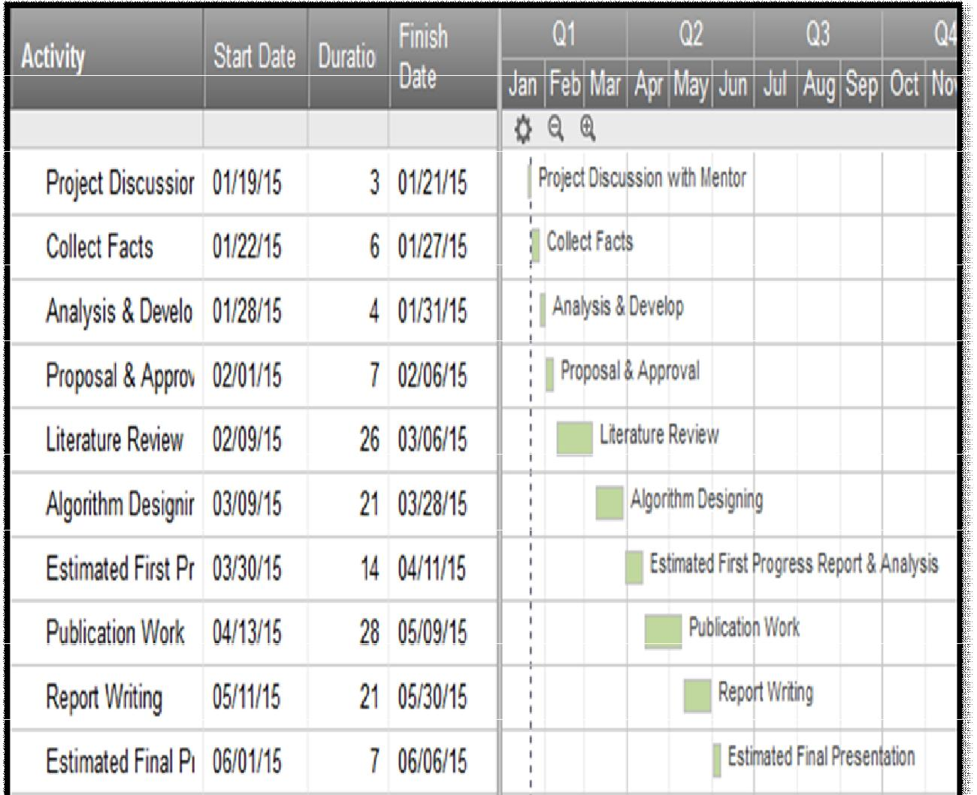

// sample Project Gantt Chart.



Note: Tool used lucid chart. (Online tool to make Gantt charts)